WordForge 2D

A SOFTWARE PROJECT PRESENTED TO THE FACULTY OF
COMPUTER SCIENCE DEPARTMENT
COLLEGE OF ARTS AND SCIENCES
DR. EMILIO B. ESPINOSA, SR. MEMORIAL STATE
COLLEGE OF AGRICULTURE AND TECHNOLOGY
www.debesmscat.edu.ph

IN PARTIAL FULFILMENT OF THE REQUIREMENTS FOR THE DEGREE

OF BACHELOR OF SCIENCE IN COMPUTER SCIENCE

ALWYN R. DALINOG
JENERALD L. GLORIA

JULY 2025

Chapter I
INTRODUCTION

Project Context
In today's computer age, typing is an essential skill for professionals, students, and anyone who uses computers on a regular basis. While many typing software exists, they are usually not customizable, with pre-set texts to type and a limited amount of performance tracking. The desktop typing master software introduced in this work closes this gap by enabling an administrator to enter custom paragraphs and track user performance on key measures such as accuracy and words per minute (WPM). The app also includes result printing for documentation or assessment purposes, and as such, it is a real-world application for professional training and education environments.
Traditional typing assessments tend to be boring and monotonous, particularly for today's students who are accustomed to interactive and captivating online experiences. Though keyboarding is still a crucial skill, the way it is instructed has not kept pace with what learners anticipate. Gamification implementing game mechanics into learning, has proved to be a successful method to enhance engagement and motivation. Typing games, with interactive feedback and competitive elements, maximize both speed and accuracy while practicing in an enjoyable and rewarding manner. By embracing such principles, the envisioned application also stands to promote improved learning outcomes through enhanced user participation.
During our preliminary research, we explored similar existing systems that offered typing-based games. However, we encountered several limitations that affected the user experience and learning outcomes. For instance, one system initially allowed users to play for ten minutes, but after three sessions, the time was drastically reduced to only two minutes per game. This restricted time frame proved insufficient for users, especially beginners, who need adequate time to familiarize themselves with the typing content and improve their skills. Additionally, many of these systems featured repetitive content, using the same words or topics for every session, which could quickly become monotonous and hinder sustained engagement.
In contrast, our system addresses these issues by offering an unrestricted number of plays with no imposed time limits, allowing users to practice at their own pace. Moreover, it includes a feature where administrators can upload custom topics to be typed, ensuring variety and relevance based on different learning goals. To further enhance engagement, we incorporated a 2D real-time fighting game mechanic, where correct keystrokes trigger attacks, transforming the typing experience into an interactive and competitive gameplay environment.
The workflow in the system is designed to be straightforward yet engaging for users. Upon launching the application, players can choose from three main modes: PvP (Player vs Player), Versus AI, or a Typing Test. In PvP mode, two human players compete against each other in real-time, using a local multiplayer setup. They battle by typing words or phrases accurately and quickly, triggering character actions such as punches, blocks, or combos. In Versus AI mode, players face off against computer-controlled monsters that increase in difficulty with each level, promoting continuous improvement in typing under pressure.
Meanwhile, the Typing Test mode allows players to select specific topics to practice. After each session, the system displays performance metrics such as Words Per Minute (WPM) and accuracy, giving users clear insight into their progress. To support tracking and assessment, the game also provides printable results at the end of every session. Additionally, the administrator has the ability to upload and manage custom typing topics, giving players fresh and relevant content to practice with. This workflow not only makes the experience interactive and fun but also ensures that users are constantly challenged and motivated to improve their typing skills.
Bernard Dalinog (Teacher), the system is required as a good tool to teach his students how to type effectively and still make the education enjoyable. In his view, the standard typing activities do not always manage to keep students focused and therefore learners find it more difficult to acquire the requisite skills. Learning-wise, students will be able to learn in an interactive learning environment with a gamification approach purely given to typing, thereby heightening their interest and motivation levels. Through such platform, he feels he would be in a better position to train his students before they join college enabling them to have good typing skills necessary in the modern studies and computerized world.
As digital jobs continue to grow, there is a significant need to improve fundamental digital literacy among students and job seekers. One foundational skill that underpins many digital careers is proficient typing, which directly affects productivity and efficiency in remote work, online freelancing, customer service, content creation, and other digital-based professions. However, many Filipinos, particularly in under-resourced areas, lack access to engaging tools that can help them practice and improve their typing speed, accuracy, and confidence in using computers and digital platforms.

In the initial data collection stage, an interview was carried out to find out the feasibility and interest in adding gameplay to typing teaching. Mos of the participants stated that making the typing learning process a game would be a very efficient method. They said that it would not only make the task more fun but also encourage students to practice typing better. In particular, they pointed out that a game mechanic in which a punch or action is initiated each time the correct word is entered would introduce an interesting and interactive dimension to learning. Furthermore, the participants saw the concept of a player-versus-player (PvP) mode as particularly appealing because it would enable students to engage with their peers in real-time competitions. This element encourages good-natured competition, further increasing motivation and making the typing exercise fun and sociable.
Republic Act No. 11927, also known as the Philippine Digital Workforce Competitiveness Act. This law aims to improve the digital skills and global competitiveness of the Filipino workforce by promoting digital inclusion, innovation, and the development of essential digital competencies. It also mandates the upskilling and reskilling of citizens to meet the demands of emerging digital careers, particularly those requiring 21st-century skills such as communication, critical thinking, and adaptability.
The system Development seeks to develop a 2D real-time player-versus-player (P v P) combat game that utilizes typing inputs as game mechanics. Instead of applying usual control systems like button-mashing or joystick, the game demands that the player input words or sentences displayed on the screen correctly and as quickly as possible in order to deliver punches, kicks, combos, or guard. The faster and more accurate the player inputs, the more powerful his or her character battles. The system also has mechanics such as power-ups, streak combos, and character skills that add to the high level of engagement and replay value. By transforming typing into the primary interaction mode under a competitive fighting game framework, the project aims to build an environment that not only entertains but also cultivates essential typing and mental abilities. The game promotes healthy competition, improves reaction time, and requires practice repeatedly overcoming the limitations of traditional typing tests. It's designed to be played by students, casual gamers, and anyone who wishes to improve their computer typing skills through an interactive and entertaining process. By conducting this research, the authors intend to show that learning games are both effective and fun and that skill acquisition especially in typing can be greatly improved when presented in terms of an engaging game that accommodates the tastes and technological lifestyles of today's students.
Fishbone Diagram. The fishbone diagram, also known as the Ishikawa or cause-and-effect diagram, is a visual tool used to identify the root causes of a problem. Structurally, the problem is the "fish head," and "bones" represent categories of potential causes, illustrating connections between factors and their effects. Often paired with the "five-whys" technique, this adaptable diagram is widely used across industries and academia for complex problem-solving and solution development (Kumah et al., 2024).

Figure 1.
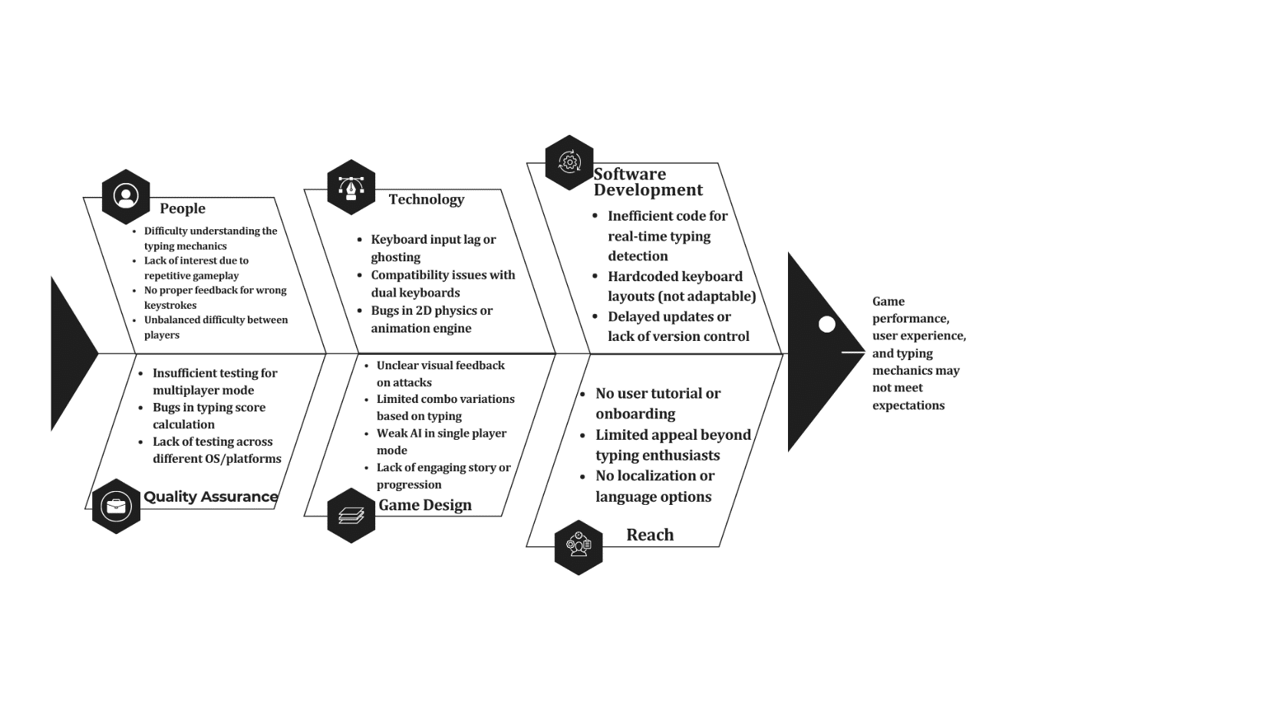
Fishbone Diagram
This fishbone diagram outlines potential issues in a typing-based game, categorized into People (player confusion, repetitive gameplay, lack of feedback, and testing gaps), Technology (input lag, compatibility bugs, weak AI, and unclear visuals), Game Design (poor onboarding, narrow appeal, and inflexible mechanics), and Software Development (inefficient code and slow updates). The root causes collectively lead to subpar performance, user experience, and typing mechanics. Addressing these through better testing, clearer feedback, optimized code, and engaging design would improve the game’s quality and player satisfaction.
Purpose and Description
The goal is to create and implement a play-to-learn game on desktop platforms, where typing is the fundamental gameplay mechanic. The system aims to improve users' typing speed, accuracy, and cognitive responsiveness by subjecting them to an interactive, competitive environment. By turning the normally passive, monotonous typing drill into a swift, dynamic game, this project hopes to render learning both effective and enjoyable. The real-time simulation requires swift reflexes and precise keystrokes, which should cause users to think quicker and type more effectively in the long run. Through constant practice in stress, users should be able to develop not only faster typing skills but also enhanced attention and decision-making.
As compared to typical typing programs that mostly use pre-provided paragraphs and boring repetitive practice, the system presents a more dynamic and adaptive approach based on individual user preferences. Users are able to upload their text materials for practice, enabling more meaningful and applicable typing exercises in relation to their interests. The game also allows users to set up specific time limits per session, providing flexibility for short bursts of practice or more extended challenges. Following every match, the game provides real-time performance feedback, monitoring statistics like words per minute (WPM) and accuracy. The system also allows for printing match results after each match, which is helpful in learning environments or for those wishing to keep track of their improvement over time. These functionalities make the game a more comprehensive and interactive experience compared to that of typical typing applications.
To promote further involvement, the game includes thrilling features that are typical of action and arcade games, including power-ups, bonus scores based on a streak, and unique character abilities. These features are intended not only to attract but also to encourage users to keep optimizing their performance. For instance, players with high accuracy or speed can have strong attacks or defenses unlocked, granting them an advantage in the game. This reward-based framework fosters repeated practice and mastery of skills in a manner more akin to play than to study.
The addition of these elements of play raises the experience from a simple typing aid to a full-fledged educational game that makes learning fun and rewarding.
The project is geared mainly towards students, gamers, and novice learners who want to improve their typing in a less stressful and more fun environment. It offers a departure from the usual classroom-based typing learning through resonance with the interests and learning habits of today's digital native generation.
Whether as an in-class supplement, a self-study aid, or a computer-related training app, the system is designed to encourage frequent practice through a fun, challenge-based experience

Objectives
The overall goal of this thesis proposal is to create a 2D real-time player-versus-player (PVP) combat game where the main control method is typing. The goal is to improve users' typing accuracy, speed, and cognitive responsiveness by creating an entertaining, gamified learning environment.
- To develop a typing learning desktop app
- Provide a module to evaluate users’ typing accuracy and speed.
- Allow users to download a certification result upon completion with data analytics.
- Enable administrators to configure typing test settings, including duration and available typing modules.
- Offer both single-player and two-player modes for a typing combat experience.
- Support competitive or cooperative gameplay to enhance user engagement through leaderboard
- Include mini-games that focus on various typing methods and skills.
- To use the Agile Model as the developmental guide of the software project.
- To test and evaluate the system using ISO/IEC 25010 software quality standards.

Scope and Limitations
The design of a learning while playing game using typing as the primary input mechanism is the primary objective of this research. Typing words or sentences displayed on the screen allows players to move and control their characters, with attacks, combos, and defenses initiated depending on the typing speed and accuracy. Power-ups, streak-based abilities, performance feedback, and post-game statistics displaying typing speed and accuracy are among the features of the game. It is meant for desktop platforms and built with regular tools and coding languages appropriate for 2D settings. The intended users are students and hobbyist gamers who want to enhance their typing in an enjoyable and competitive atmosphere. Nevertheless, the study's scope is on desktop platforms only; support for mobile devices, tablets, and VR/AR equipment is not included. Multiplayer is limited to local two-player games, with no online matchmaking or networked play. The game concentrates entirely on building typing speed, accuracy, and responsiveness, rather than addressing grammar, spelling, or language understanding. It might also be unsuitable for expert typists or individuals with advanced typing abilities. The system also lacks adaptive difficulty, so players of varying skill levels might not always see their matches balanced. Pre-designed characters and game environments, and players cannot upload or add their assets. Typing content is pre-curated by the administrator and not dynamically loaded. Users are, however, provided with the choice of selecting the time limit they prefer and uploading their own custom paragraphs or letters to type, in order to have a more customized and flexible training process. Leaderboards or cloud-based stats tracking are not supported. Lastly, the system demands a physical keyboard, since touch support is not included.
Definition of Terms
The following terms are defined basically by simplicity and a common understanding of the project:
2D Game. A two-dimensional video game where characters and environments are rendered in flat graphics.
Administrator. The person in charge of managing the app content, such as uploading typing paragraphs and monitoring results.
Agile Model. A flexible and iterative software development approach that emphasizes collaboration and customer feedback.
Cognitive Responsiveness. The mental ability to react quickly and accurately to stimuli, such as on-screen text in a game.
Combat Game. A type of game genre focused on fighting mechanics, where players control characters to battle each other.
Competitive Learning. An educational approach where learners engage in friendly contests to boost motivation and skill acquisition.
Custom Paragraphs. User- or admin-uploaded text that can be used for typing exercises in place of pre-set content.
Desktop Application. A software program designed to run on a desktop or laptop computer, not on mobile or web platforms.
Digital Inclusion. Efforts to ensure all individuals have access to digital tools and the skills to use them.
Digital Literacy. The ability to use digital tools and platforms effectively, including basic computer and typing skills.
Functionality. The degree to which the software performs its intended tasks correctly.
Gamification. The integration of game mechanics into non-game contexts to increase user engagement and motivation.
Interactive Learning. A learning style that uses active engagement, such as games, to improve understanding and retention.
ISO/IEC 25010. An international standard for software product quality, including criteria such as functionality and usability.
Maintainability. The ease with which the software can be modified to fix bugs, improve performance, or adapt to changes.
Match Result Printing. A feature allowing users to generate and print their performance report after a game session.
Philippine Digital Workforce Competitiveness Act (RA 11927). A law aimed at enhancing the digital skills of Filipinos to compete in a global digital economy.
Physical Keyboard. A hardware input device used for typing, necessary for operating the system in the absence of touchscreen support.
Power-Ups. In-game items or bonuses that give the player a temporary advantage, such as enhanced attack power or speed.
PvP (Player vs. Player). A multiplayer game mode where two players compete against each other in real time.
Real-Time Feedback. Immediate evaluation and display of a user’s performance, such as WPM and accuracy during or after a match.
Reliability. The software’s ability to function under specified conditions consistently over time.
Security. The ability of the system to protect data and withstand malicious threats or unauthorized access.
Simulation. A digital recreation of a real-world activity, such as typing, within an interactive virtual environment.
Streak Combos. A series of successful actions (e.g., correct words typed) that trigger rewards or special abilities in the game.
Typing Accuracy. A metric used to evaluate how correctly a user types without making errors.
Typing Game. A type of educational game where users improve typing skills through interactive, game-based tasks.
Typing Speed. A measurement of how many words a person can type per minute, commonly abbreviated as WPM (words per minute).
Typing. The act of inputting text using a keyboard, often measured by speed and accuracy.
Usability. The ease of use and user-friendliness of the software for its intended audience.

Chapter II
REVIEW OF RELATED LITERATURE
This chapter reviews relevant existing literature that was instrumental in building the software project, serving as the primary source of information throughout its development.
Human Resource Management
This study proposes the TRRUST framework and 25 recommendations to address a "credibility crisis" in HRM research by enhancing transparency, reproducibility, and replicability. The authors argue these practices are vital for improving research quality, guiding evidence-based HR decisions, building public trust, and ultimately fostering more effective and ethical workplace policies (Aguinis et al., 2025).
This study proposes an expanded, multidimensional conceptualization of scholarly impact beyond just other researchers, to include various external stakeholders. The paper also outlines measures for these dimensions and extends the CORE performance model to introduce Scholarly Impact Performance (SIP). It provides actionable recommendations for individuals and organizations in diverse institutional contexts to enhance SIP, ultimately offering a broader understanding, measurement, and strategies for improving scholarly impact (Aguinis & Gibson, 2025).
This study, conducted in Ashgabat, Turkmenistan, investigated the correlation between strategic human resource management functions and intellectual capital components among 151 professional and higher-level employees. Using a researcher-made questionnaire validated by experts (Cronbach's alpha 0.93), the findings revealed a significant relationship between the "learning" and "participation" functions of strategic human resource management and human capital (Dursun & Yawar, 2025).
This study aimed to develop a balanced scorecard (BSC) for quantitatively assessing the efficiency of strategic human resource management (HRM) in Russian IT companies. Analyzing existing methodologies, the researchers identified key HR factors and goals specific to the IT sector. They developed a BSC structured across financial, client, process, and training/development perspectives. The study concluded that their BSC, which accounts for intellectual human resource specifics, offers a valuable tool for strategic HRM in Russian IT companies seeking competitive advantages amidst skilled personnel shortages, addressing the lack of universal HRM efficiency assessment approaches (Lukyanov & Borodin, 2025).
This qualitative study at SD Negeri 170 Ogan Komering Ulu (OKU) investigated how human resource management (HRM) impacts educational quality, examining its implementation, obstacles, and supporting factors. Through observation, interviews, and documentation, the research found that HRM, including quality improvement, implementation, and supporting factors, was optimally executed, leading to improved educational quality (Qutni et al., 2021).
This article analyzes the extensive potential of artificial intelligence (AI) in human resource management (HRM), from automating tasks like recruitment, payroll, and documentation, to optimizing performance management. It argues that AI can significantly enhance decision-making effectiveness in HR functions, representing a revolution in HRM practices. The paper supports this thesis with a literature review and a brief bibliometric analysis from the Scopus database, highlighting the increasing academic interest in AI applications in HRM (Smolarek & Budzynowski, 2025).
This study emphasizes the critical role of human resource management (HRM) in education, asserting that it is essential for integrating, maintaining, and motivating teaching and other staff to achieve institutional and national development goals. The authors argue that effective HRM is indispensable for rapid socio-economic development and efficient service delivery, concluding that a strong, skilled, and motivated HR program is fundamental to the success of any educational system's objectives (Suganthi et al., 2025).
HR Automation
Alvi's (2024) study reveals that Artificial Intelligence (AI) is revolutionizing Human Resources (HR) by enabling smarter decision-making, enhancing employee experiences, and fostering empowerment. By automating routine tasks, AI allows HR professionals to focus on strategic initiatives. Additionally, AI-powered analytics provide valuable insights into employee behavior, leading to proactive issue resolution and increased engagement across all HR functions. Ultimately, AI helps organizations build stronger employee connections and cultivate an empowered workforce.
Bansal (2023) highlights that organizations need to effectively manage their staff to maintain a competitive edge in today's fast-paced business environment. While HR departments handle the entire employee lifecycle, many of their processes are bogged down by time-consuming, repetitive tasks, leaving little room for strategic decision-making. The concept of "Automating HR Processes: Streamlining Employee Management" has emerged as a crucial solution to these challenges, enabling HR to reach its full potential.
Gour et al. (2024) observe that automated systems significantly impact Human Resource Management (HRM) in multinational corporations. They argue automation is vital for aligning HR with business strategies, optimizing resources, and streamlining processes, leading to more efficient HR activities, real-time data for faster decisions, and reduced errors and processing times. However, the study also warns of risks such as over-automation, potential cost increases from the need for more manual checks, employee disengagement, and the risk of unethical behavior due to insufficient human oversight.
This study by Krishnan and Ganesh (2024) investigates how artificial intelligence (AI) and automation are transforming human resources (HR) practices in IT companies. Using a mixed-methods approach with surveys and interviews, the research explores AI's influence on HR functions like recruitment, training, performance management, and employee engagement. The study found that AI and automation can significantly streamline administrative tasks, improve data-driven decision-making, and personalize employee experiences within HR.
Malina et al. (2024) state that Human Resources (HR) departments handle numerous strategic tasks, from hiring to termination, including employee monitoring, payroll, and benefits management. To simplify these complex responsibilities, organizations globally are investing in HR automation to optimize human capital decisions. Companies are specifically seeking applications that can streamline HR processes, ensure data retention and control, enhance communication, provide connectivity across the organization, and support a futuristic approach to HR management.
Murphy (2024) conducted a semi-systematic literature review on automation and employment, finding that despite ongoing debates, automation generally doesn't cause job displacement. Instead, it tends to lead to new job creation, task expansion, and skill development. The study recommends that organizations use employee augmentation alongside automation to boost productivity, improve work design, build trust, and foster creativity, while also emphasizing the critical need for continuous employee upskilling.
Parveen et al. (2024) explore how automating HR functions, particularly through AI, enhances organizational growth by improving efficiency and administration. Their research aims to demonstrate AI's capacity to streamline repetitive tasks, offer personalized employee experiences, and reduce human error, ultimately making companies more employee-centric. The study emphasizes that AI's benefits extend across various HR procedures, showcasing its critical role in achieving high-quality, productive results in the continuously expanding technology market.
Pazare (2024) explores the transformative integration of Artificial Intelligence (AI), particularly Natural Language Processing (NLP), in revolutionizing Human Resources (HR) management. The study specifically examines the pivotal roles of the Legal Language Model (LLM) for automating legal document interpretation and the Language Model for Attribute-based Matching (LAMA) for optimizing talent acquisition. By integrating these AI tools within a Streamlit-based interactive framework, the research demonstrates significant improvements in recruitment precision, legal compliance, and overall workflow streamlining, advocating for the adoption of AI-driven solutions to enhance strategic HR growth in organizations.
Shanmugam et al. (2024) conducted a systematic review of literature on AI and automation in Human Resource Management (HRM), revealing a divided academic perspective between those highlighting transformative potential and those urging caution and further research. Their study provides a nuanced understanding of these technologies' multifaceted implications, from functional applications to strategic considerations. Ultimately, the authors advocate for informed decision-making that balances technological efficiency with ethical considerations, recognizing the profound and broad impact of AI and automation on HRM and beyond.
Sundari et al. (2024) investigate the impact of Artificial Intelligence (AI) in wHuman Resources (HR) management on employee engagement and operational efficiency. Through automating tasks like data management and payroll, their research finds that AI significantly boosts operational efficiency and enhances employee engagement via personalized experiences. While noting challenges like employee resistance, the study advocates for strategic AI integration to improve HR effectiveness and foster a more engaged workforce.
Sutharsan and Vijayakumar (2023) highlight that HR automation in the IT industry effectively uses technology to streamline diverse HR tasks, from payroll to performance tracking. This automation frees HR professionals from manual processes, allowing them to focus on strategic areas like employee engagement and retention. By improving data tracking and reducing administrative burdens, automation significantly enhances overall workplace efficiency and productivity.
Taslim et al. (2024) investigated how automating work processes influences HR decision-making. Their findings indicate that employee performance acts as a crucial link in this relationship. Furthermore, the study introduces "Emotionally Aware AI Decision Making (EA-AIDM)" as a key factor for effectively using AI to improve HR decisions.
Tiwari et al. (2024) investigated how machine learning algorithms can be applied in HR management, concluding that AI has the potential to automate routine tasks, improve operational efficiency, and facilitate strategic decision-making, which would ultimately benefit IT companies.
Vijai and Mariyappan (2023) examine the transformative impact of automation on Human Resources (HR), highlighting its role in revolutionizing traditional HR operations and workforce management. Their study emphasizes how automation, through technologies like RPA, AI, and ML, drives benefits such as increased efficiency, accuracy, and improved employee experiences across various HR functions. They conclude that embracing HR automation leads to significant organizational advantages, allowing HR professionals to focus on strategic initiatives and ultimately contributing to better talent management and overall business success.
Westover (2024) examines how HR automation can significantly enhance employee engagement. The article outlines how automating administrative tasks not only streamlines processes and improves the overall employee experience but also liberates HR professionals to concentrate on more strategic, engagement-focused initiatives. It explores specific use cases where automation has a profound impact, such as onboarding and performance management, while also discussing strategies to overcome implementation challenges, ultimately aiming to empower HR practitioners to cultivate a more engaged and productive workforce through technology.
Document Generation
Abisornam, M. (2025). This study developed a web-based Document Verification System using HTML, CSS, JavaScript, Node.js, and OCR to automate and improve the accuracy of document validation. Users upload documents (e.g., IDs, certificates), from which the system extracts text via OCR and cross-verifies it against databases or patterns. The platform provides an intuitive UI, real-time extraction, authenticity checks, and detailed reports that flag inconsistencies and potential forgeries, offering suggestions for failed verifications. This secure, scalable, and user-friendly solution is particularly beneficial for institutions and HR departments, aiming to reduce manual workload and prevent fraud through intelligent processing.
Aprilina, V., Dompak, T., Salsabila, L., & Lodan, K. T. (2025). This study, a literature review, examines the impact of e-Government on public grievance administration in Indonesia, focusing on efficiency, openness, and accessibility. It finds that digitalizing public services using ICT significantly improves complaint resolution and accountability, aligning with good governance principles. However, the research also identifies persistent challenges related to infrastructure, human resources (digital literacy), and community engagement. To maximize e-Government's benefits, the study recommends improving technological infrastructure, enhancing human resource skills, and boosting public awareness to achieve more effective and responsive public services.
Latupeirissa, J. J. P., Dewi, N. L. Y., Prayana, I. K. R., Pramana, I. B. G. A. Y., et al. (2024). This research investigates the digital transformation of public service delivery and its impact on local governments, acknowledging the risk of a digital divide. Through a comprehensive literature review and case studies found via Scopus, the study concludes that digital transformation enhances efficiency, citizen involvement, and government accountability. It identifies organizational efficiency, citizen expectations, and higher authority demands as key drivers, emphasizing technological readiness. Future research should address inclusivity, accessibility, cost management, and data security concerns.
Ononiwu (2025) demonstrates how WordPress can be used to develop scalable, secure, and user-friendly web-based HR systems, streamlining functions like recruitment, staff deployment, and document management through middleware, API integrations, and automation tools.
Putri, S. A., Dewi, I. K., & Afrina, A. (2025). This study aimed to develop a web-based information system for managing incoming and outgoing letters at the Baloi Permai Subdistrict Office, driven by identified needs for improved efficiency and transparency, addressing issues like lack of integration, processing delays, and limited public access in the current manual system. Developed using the Laravel framework (PHP and MySQL) and designed with UML, the system features user management, document tracking, and report generation. Black-box testing confirmed its functionality. The researchers anticipate the system will enhance record accuracy, accelerate document processing, and improve public accessibility, with potential for broader government adoption.
Shen et al. (2020) developed a method and device for generating document templates that improves efficiency. Their system allows users to define a template style and automatically fills it with content based on input data and a defined mapping, streamlining document creation.
Contract Tracking
(Acedo, 2025) developed a web-based document tracking system with QR-code technology for Catanduanes State University (CatSU) to combat inaccuracies and delays in document management. Designed for efficiency and compliance with RA 11032, the system uses QR codes for real-time tracking, reducing human error and increasing transparency. Developed with standard web technologies, it achieved an "Excellent" rating (mean 4.94) across ISO/IEC 25010 software quality criteria. Findings indicate the system significantly improves CatSU's document management, with recommendations for future expansion.
(Castro et al., 2022) introduces DocTrack, a web-based document tracking system for the University of Northern Philippines, designed to centralize document management from creation to approval and move towards paperless transactions, aligning with ISO standards. Developed using a modified Waterfall Model, the system offers six core functionalities: document upload, tracking, display of received, pending, and declined documents, and archiving, with integrated security measures. The research found that DocTrack significantly improves document tracking and consolidation for the university, though it recommends acquiring necessary equipment to fully support the system.
This study presents UPC Sentinel, an algorithm that accurately identifies upgradeability proxy contracts (UPCs) in Ethereum DApps. UPCs are crucial for updating DApps built with immutable smart contracts. The research emphasizes the need for accurate UPC detection to understand DApp maintenance and ensure transparency and auditability. UPC Sentinel, using static and dynamic bytecode analysis, demonstrated superior performance with near-perfect accuracy (99%) and excellent precision (100%) and recall (99.3%), outperforming existing methods.
This study developed a centralized digital workstation for Manuel S. Enverga University Foundation Candelaria Inc.'s Dean's Office to address inefficiencies and document loss from multi-platform use. The system manages inter-departmental documents, tracks them via codes, and archives completed transactions, aiming to streamline workflow and prevent document loss. Utilizing an Agile development approach, the researchers anticipate significant improvements in the university's document cycle (Hermosa, 2023).
Kim and Kim (2024) propose a series of structured and adaptive processes for tracking and verifying blockchain transactions. Their study advocates for using hash chain-formatted contracts when leveraging blockchain technology for tracking and verification across different institutions.
Liu et al. (2020) describe an intelligent smart contract data tracking method and device for blockchain-deployed smart contracts. When a smart contract is called, a virtual machine executes its bytecode. This process involves obtaining external input data, generating a corresponding "stain identifier," storing both in a designated storage space, and then transmitting the external input data and its stain identifier if the data being transmitted is identified as the original external input. This allows for tracking data origin within blockchain transactions.
This study developed TrackERB, a web-based system for Holy Name University's Ethical Review Board, to solve issues with manual research submission management like poor monitoring, unclear statuses, and communication gaps. Built with Laravel and integrating various tools, TrackERB centralizes tracking, provides real-time updates, and ensures timely reviews for all users. A usability test scored 91.19 (above average), confirming TrackERB significantly improves submission tracking, accessibility, notification automation, and transparency.
Sunatha et al. (2023) analyzed the impact of a Contract Change Order (CCO) on the Peladokan Pelt Road Improvement Project, specifically examining its effect on project completion time. Using Microsoft Project and tracking techniques on plan and realization data, they found that the CCO, involving modifications to 23 jobs (cuts, additions, volume changes), led to the project being completed 97.38 days ahead of schedule, advancing the completion date by 22.62 days. This study highlights the importance of tracking modifications in construction projects to assess their impact on timelines.
Tracking and tracing systems record product movement from origin to destination, with traceability being a key component. The entire process, from order to final delivery, benefits significantly from effective tracking. Blockchain technology enhances the security of these tracking systems, offering a superior alternative to methods like QR codes, RFID, and manual delivery, particularly in fields where safety and trust are paramount. This research aims to highlight blockchain's contribution to improving the security of tracking management.
Personnel Database
This study by Chatterjee et al. (2021) investigates the negative consequences of HR analytics (HRA) via privacy calculus theory, despite HRA's benefits. Using a PLS-SEM validated model with 315 respondents, it identifies key risks: employee privacy compromise from unauthorized data access, security concerns from uncontrolled HRA, and increased risk from non-consensual tracking. The research stresses the necessity of appropriate regulation and leadership support for HRA to mitigate these privacy and security issues.
This study by Dreichuk and Sytnyk (2025) qualitatively examines HR analytics' role in risk management within HRM systems. Through literature review and case studies, it demonstrates that HR analytics, particularly with AI and big data, enhances risk identification and mitigation by providing data-driven, predictive insights into workforce challenges. The research emphasizes HR analytics' practical benefits for improved workforce planning, reduced turnover, and compliance, ultimately boosting organizational competitiveness by proactively addressing risks.
This study by Hazafi and Pintér (2020) examines the impact of global HR reinterpretation and civil service shifts on Hungarian Public Administration's personnel management. It identifies HR's evolving strategic role in organizational development and policy, alongside a growing need for HR Knowledge Exchange Systems due to increased organizational decision-making and deregulation. The authors present the HR Knowledge Exchange System and Expert Network as a solution, providing online and offline support (academic database, forums, counseling) to align with HR reorganization and promote a 'Healthy Organisation Model’.
This article by Kotsur et al. (2024) examines the integration of personnel audit and HR analytics as crucial tools for effective, adaptive human resource management. It defines each tool, then conducts a comparative analysis to highlight their combined benefits for objectively assessing HR systems, forecasting, and making strategically balanced decisions. The study argues that integrating these tools increases transparency, reduces risks, and improves adaptability by identifying factors affecting motivation, turnover, and satisfaction, ultimately enhancing personnel policy, labor productivity, and organizational competitiveness.
This article explores digital transformation's role in HR technology implementation, emphasizing its economic importance and integration via digital platforms. The study validates a competence-based approach for assessing personnel and outlines the goals and prerequisites for digital HR transformation, noting its varied impact across industries (Nadtochii, 2024).
This study by Svatiuk et al. (2022) investigates digitalizing HR manager functions at Private Austrian Investments LLC. It analyzes the company's HR processes, finding an average digitalization level in its information support. The research proposes recommendations for enhancing the HR manager's digital work, including implementing a digitalization strategy and a Telegram chatbot. Key digital HR responsibilities outlined include automating HR functions with AI, online training, cloud service integration, talent reserve database creation, predictive analytics, and using VR for talent acquisition and virtual corporate culture. The study's practical significance lies in its actionable recommendations for improving HR recruitment through a digitalization-focused personnel strategy.
This article by Zachosova et al. (2025) advocates human-centrism as an HR management philosophy to enhance recruitment, motivation, and intellectual/personnel security. It argues prioritizing employee needs fosters loyalty and self-development, crucial for economic success. The study recommends integrating human-centric practices like digital and individualized recruiting, diversified motivation tools, and the StrengthsFinder test. Ultimately, human-centric HR enables precise risk mapping and conflict prevention, ensuring enterprise stability and growth.
Certificate of Employment
Anwar and Hermina (n.d.) investigated the impact of job training and professional HR certification on job opportunities at PT Akasia Multi Talenta, a company in Indonesia, in the context of the country's unemployment issues. Using descriptive and verification methods on a sample of 171 participants, their analysis revealed a positive effect of both training and certification on job opportunities. The study aims to offer insights and recommendations for individuals, organizations, and policymakers to support inclusive and sustainable economic development.
Bizzarro et al. (n.d.) analyze Italy's 'certification of employment contracts,' a voluntary, indirect labor market regulation. This process involves labor law experts reviewing contracts for legality, fairness, and alignment with organizational needs to prevent future disputes, with certification granting a legal presumption of fairness.
Dundon and Wilkinson (2020) examines Human Resource Management (HRM), asserting that its application is not neutral and often reflects corporate interests, creating a gap between rhetoric and workplace realities. Using the controversial "#996 approach" (12-hour days, 6 days a week) as an example, the authors argue that such practices, despite being framed as opportunities, ultimately prioritize increased wealth for leaders over employee well-being and long-term productivity. The book aims to offer evidence-based case studies for critical analysis in HRM education.
Ghamri et al. (2020) point out challenges in verifying employment records due to the lack of standardized award certificates and the isolated nature of current employment systems, which often don't share history with educational institutions or the private sector. Their research suggests that distributed systems could significantly reduce the costs of verifying and authenticating records while offering flexibility in managing trusted documents like employment history, certificates, and resumes.
Jadhav et al. (2022) propose an Ethereum blockchain-based system to combat certificate forgery. This system enables universities to generate unique, verifiable digital certificates with hash codes via a web portal, allowing for easy, secure, and time-saving authentication and verification.
Krishna et al. (2024) propose an E-Certificate system to automate and streamline the entire digital certificate lifecycle. This system enables administrators to generate, store, and distribute secure certificates, allows recipients to manage them, and provides verifiers with efficient authentication tools, ultimately reducing administrative burdens and enhancing security.
R et al. (2024) propose a new system using open-source software and blockchain technology to tackle the widespread problem of counterfeit and unverified digital certificates. This system would enable the creation of customized, secure digital certificates stored in a digital locker, allowing easy validation by organizations. Ultimately, this aims to provide tamper-proof and reliable certificate management, benefiting both issuers and recipients by ensuring authentic credentials in the job market.
Saju et al. (2024) identify a significant delay in the hiring process due to the time-consuming verification of academic credentials, where employers must authenticate certificates with the issuing organization. To combat this, they propose blockchain technology as a solution. Blockchain, with its verified distributed ledger and cryptography, can prevent academic certificate forgery and provide a standardized platform for document storage and access, thereby significantly reducing verification time and expediting the overall selection process.
Suzuki and Kotani (2014) describe a computer-executed method for generating electronic certificates. This method involves receiving specific information and configuration data from a tamper-resistant communication device. If this received information matches pre-stored data, a communication address for the device is determined. Finally, an electronic certificate is generated, incorporating some or all of the specific and configuration information along with the determined communication address, and then transmitted back to the communication device.
Agile Model
Ballamudi (2022) examines Agile methodologies, highlighting their benefits in enhancing project flexibility, customer satisfaction, and product quality. The article also identifies and explains the inherent constraints associated with using Agile approaches in both software and web engineering.
Coelho et al. (2020) present a multidimensional maturity evaluation model for agile practices in organizations. Driven by the need for greater perceived value and customer proximity, the model assesses agile implementation from individual and development team levels up to product, project, and program management, guided by agile values and principles. Developed through a systematic literature review, this model aims to help organizations identify their current agile status and promote further agile adoption, filling a gap in existing frameworks.
Esang et al. (2024) present a case study on using Agile methodology, specifically Scrum, to develop a web-based transcript and result computation system for Polytechnic Ukana. The study details how this iterative approach fostered flexibility, teamwork, and timely delivery, enabling the team to adapt to evolving needs and efficiently solve problems. The successful on-schedule deployment of the system, which met all requirements and improved accuracy and efficiency, demonstrates Agile's effectiveness for similar educational software development projects.
Gray et al. (2018) investigated how various Agile project management methodologies Scrum, Extreme Programming (XP), and the Hybrid model could be integrated into computer science and information systems academic curricula. Through two experiments comparing the performance of these methodologies based on velocity, defects, and time to completion, they found that XP is best suited for early courses, Scrum for intermediate levels, and the Hybrid model for senior capstone projects, thus providing guidance for incorporating Agile into academic settings to prepare students for industry.
Kalwar et al. (2023) propose a new iterative development model for web applications. The study aims to overcome the limitations of traditional methods by accurately responding to dynamic requirements, minimizing technical debt, and maintaining quality, thereby simplifying web application development.
Romano and Cunha (2021) introduced WebAC-MDD, an Agile and Collaborative Model-Driven Development method for Web applications. This method aims to boost productivity and reduce unvalued modeling/documentation efforts by transforming agile models into Web application source code using their novel UML profile, Web Agile Modeling Language (Web-AML).
Stepanov (2021) investigates the applicability of Agile methodologies (like Scrum, Kanban, and Extreme Programming) for implementing large-scale Corporate Information Systems, specifically ERP systems, which typically have multi-year implementation projects. The paper aims to determine if Agile, commonly used for smaller developments, can be effectively utilized in such extensive and complex enterprise-wide projects.
Thomas and Bindu (2022) compare traditional and agile software development methodologies, defining their processes and evaluating their impact on product delivery. The study addresses the challenge firms face in choosing between these approaches for stable product creation, considering factors like project timeframe, requirements, and resources. They also present the implementation of a Scrum agile model within a software firm specializing in web applications. The core finding is a comprehensive review and comparison of these methodologies to guide effective software development.
Wisnumurti et al. (2022) applied the Agile Development methodology to address manual transaction and stock recording issues at the Kinanti Sembako Store. Their study aims to demonstrate how an agile-developed sales information system involving analysis, design, development, testing (using black box testing), deployment, revision, evaluation, and maintenance can streamline data processing, reporting, and management of goods, customer, purchase, sales, and profit/loss data, ultimately resolving the store's current inefficiencies.
ISO/IEC 25010
Cai et al. (2020) effectively utilize the ISO/IEC 25010 standard to quantify the quality of B abstract machines, which are foundational to software development in the B method. By proposing criteria based on this international standard, they successfully measure abstract machine quality using equations and model checking, demonstrating ISO/IEC 25010's utility in formally verifying and enhancing software quality at the design level. This application highlights the standard's effectiveness in providing objective, quantifiable assessments of software components.
Geoloni, et al., (2023) utilized the ISO 25010:2011 method, focusing on its usability characteristics, to test an implemented Human Resources Information System (HRIS). This application of the ISO standard allowed them to systematically analyze employee challenges, particularly identifying consistently low scores in "learnability" for both frequent and rare users. This precise identification of a key weakness, enabled by the ISO 25010 framework, led to concrete recommendations for improvement, such as user guides and training, to enhance overall system comprehension.
Moumane et al. (2024) effectively utilized the ISO/IEC 25010 standard to assess the software product quality of reproductive health mobile applications, highlighting its instrumental role in identifying specific strengths and weaknesses. By examining characteristics such as functional suitability, reliability, usability, efficiency, and maintainability, their study revealed that functional suitability significantly influences other key quality attributes like operability, performance efficiency, reliability, and security.
Mulyawan et al. (n.d.) conducted a literature review to explore the widespread application of the ISO/IEC 25010 model in software quality measurement. Their study emphasizes the standard's utility for assessing diverse information systems, including those in academia, government, and private sectors, as well as mobile applications and games. The findings highlight that ISO/IEC 25010 is a crucial guide for determining software quality, stressing that accurate assessment depends on selecting relevant aspects and employing appropriate testing methodologies.
Nurunnisa et al. (2024) assessed the quality of the "BETUNAS" scholarship information system by applying the ISO/IEC 25010 standard. Their study extensively evaluated the e-Government platform across all eight quality characteristics, including functional suitability, performance efficiency, compatibility, usability, reliability, security, maintainability, and portability. The findings consistently showed that the BETUNAS system largely conformed to the standard, indicating its overall good quality and providing a detailed understanding of its strengths and areas for potential improvement.
In their study, Nuzula and Rochimah (2023) highlight ISO/IEC 25010 as an international standard for evaluating information systems, specifically for assessing "product quality" by examining the characteristics of an information system. They assert that this standard is a suitable framework for determining the degree to which a system fulfills both stated and implied stakeholder needs, thus providing valuable insights into its quality.
Purbaratri, et al., (2023) examines how ISO/IEC 25010 and the SPBE (Electronic-Based Government System) Framework were combined to assess software quality and maturity in Indonesian Smart City applications. By systematically mapping the two models' attributes, the researchers established a foundation for a governance framework aimed at enhancing the quality of Smart Government software.
Rumabar and Maria (2023) utilized the ISO/IEC 25010 standard to conduct a comprehensive quality evaluation of ShopeePay from the user's perspective. By providing a structured approach to quantify user satisfaction and identify areas of strength and weakness, the model proved instrumental in offering concrete, actionable insights for system developers and management to improve the application's overall quality and address user concerns.
Sudianjaya and Rochimah (2023) investigated the functional suitability of a Loan Origination System in the banking sector by combining ISO/IEC 25010 with the Goal Question Metric (GQM) Approach. Their study aimed to ensure the system met critical requirements, especially for rapid loan processing. While the GQM method yielded numerically lower results, it provided more objective insights from users about how well the system aligned with the institution's goals, proving valuable for future development and improvement efforts.
Surachman (2024) emphasizes ISO/IEC 25010 standards as a critical tool for improving user experience on online sales platforms. The study leverages this framework to evaluate crucial aspects like reliability, security, and system efficiency on platforms such as Tokopedia, Shopee, and Lazada. By using ISO/IEC 25010, the research aims to provide concrete insights into factors affecting user satisfaction, and its findings are intended to guide system enhancements that directly address user needs.
Velasquez et al. (2023) developed and evaluated the Office of the Senior Citizen Affairs Information Management System with Analytics (OSCA-IMSA) using the ISO/IEC 25010 criteria as a core evaluation tool. Their study assessed the system across all eight key quality characteristics, including usability, reliability, performance efficiency, functional suitability, security, portability, maintainability, and compatibility. The consistent "highly" ratings from both system users and IT experts confirmed the system's strong performance and adherence to the ISO/IEC 25010 Software Product Quality Standard, leading to its recommendation for deployment.
Yatsyshyn et al. (2023) highlight the effectiveness of the ISO 25010 international standard in developing a formalized approach for evaluating the performance of relational database management systems (DBMS). By leveraging the standard's defined attributes and metrics for performance characteristics, their study created a structured methodology to quantitatively assess DBMS quality. This allowed for a flexible and formal process to compare and select the best DBMS alternatives, demonstrating ISO 25010's practical value in optimizing computer system design based on specific requirements.
In their study, Yulianty and Kurniawati (2021) utilize ISO 25010:2011 as a crucial model for conducting a quality analysis of the Bios Portal Website developed for a private banking company in Indonesia. They emphasize that this standard is essential for measuring the quality of software products, especially in critical sectors like banking where efficiency and effectiveness are paramount. By applying the ISO 25010:2011 method, through techniques such as literature study, observation, black box testing, and questionnaires, their research effectively quantified the quality of the Bios Portal website, yielding a score of 4.87. This outcome demonstrates the standard's utility in providing a structured framework for assessing software quality and identifying specific areas, such as performance efficiency and maintainability, for recommended improvements.
Zhang et al. (2022) developed a hierarchical quality assessment model that extends the ISO/IEC 25010 standards to address the specific needs of mixed-source software. By integrating new attributes like "community intensity" and "autonomy controllability" with their corresponding metrics, their model effectively evaluates mixed-source software's unique quality aspects. The study confirms that this enhanced framework provides a flexible and effective means to assess such software, demonstrating the adaptability of the ISO/IEC 25010 standard for specialized evaluation requirements

.

Chapter III
METHODOLOGY
This chapter presents the methodology employed in the development of the system that enables users to learn while playing a typing-based game. The system also provides a feature that allows administrator to upload their own paragraphs and set a desired time limit in minutes for each typing session. This chapter outlines the step-by-step process of how the system was planned, developed, and tested to ensure functionality and performance. Additionally, it details the technical specifications, tools, programming languages, and platforms used throughout the development. The chapter also discusses the software development model adopted in the project, along with a software cost estimation that guided the project’s resource allocation and timeline.
Project Design
The targeted software project, the so-called WordForge 2D is a desktop interactive game application developed within the Godot Engine, a flexible and robust open-source package that is particularly well adapted to the design and development of 2D games. All of the core gameplay mechanic will be implemented in the system through the use of GDScript, the native programming language of Godot, including character movement, power-ups, streak combos, and real-time PvP interactions that are activated based upon the typing accuracy and typing speed of the players.
Even when the server-side is unavailable, all system data as well as the user profile, typing test results and custom paragraphs uploaded by administrator will still be available in the local storage. In this way, the application can be utilized in complete offline mode and its data easily manageable without using the internet connection or cloud services. The front-end user interface will be structured as a clean, ranging, and user friendly to ease the system to every casual and competitive user.
In the drawing of the character sprites, animations, and other images the development crew will use Ibis Paint, which is a flexible piece of digital painting software that has adjustable brushes, complex layer features, and high resolution output. Using this software, it will be able to create high-quality original graphics that depict the competitive, engaging, and educational characteristics of the game.
The system would entail a gamified experience of typing skills enhancement with an unlimited number of typing practices and duration configurability, as well as content generability.
As opposed to standard typing software models, where the basis of motivation and learning involves repetitive drills and preset text, Type Combat uses competitive gameplay, real-time performance tracking, and an interactive feedback mechanism to keep the performer driven. Much attention will be paid to the provision of the performance of a game, simple control, and optimization of the local data.
The project will be backed by visual illustrations like the use case diagrams, data flow diagrams, and system architecture diagrams, so as to be able to visualize and provide clarity to the development and documentation. These shall demonstrate the technical design, user interactions and the structure of the whole system to act as a guideline during the development period.
The presentation and analysis of this software project will incorporate various diagrams and visual aids to clearly demonstrate the system's operations.
Use Case Diagram. A user case diagram, A UML use case diagram serves as a primary tool for defining the system or software requirements of a new program still in development. Use cases describe the intended behavior of the system (the “what”) without detailing the specific approach or process to achieve it (the “how”). Once defined, use cases can be presented both textually and visually through a use case diagram. The core idea of use case modeling is to design a system from the perspective of the end user. It provides an effective way to communicate how the system should behave in terms familiar to the user, by outlining all system actions that are externally observable.
Figure 2.
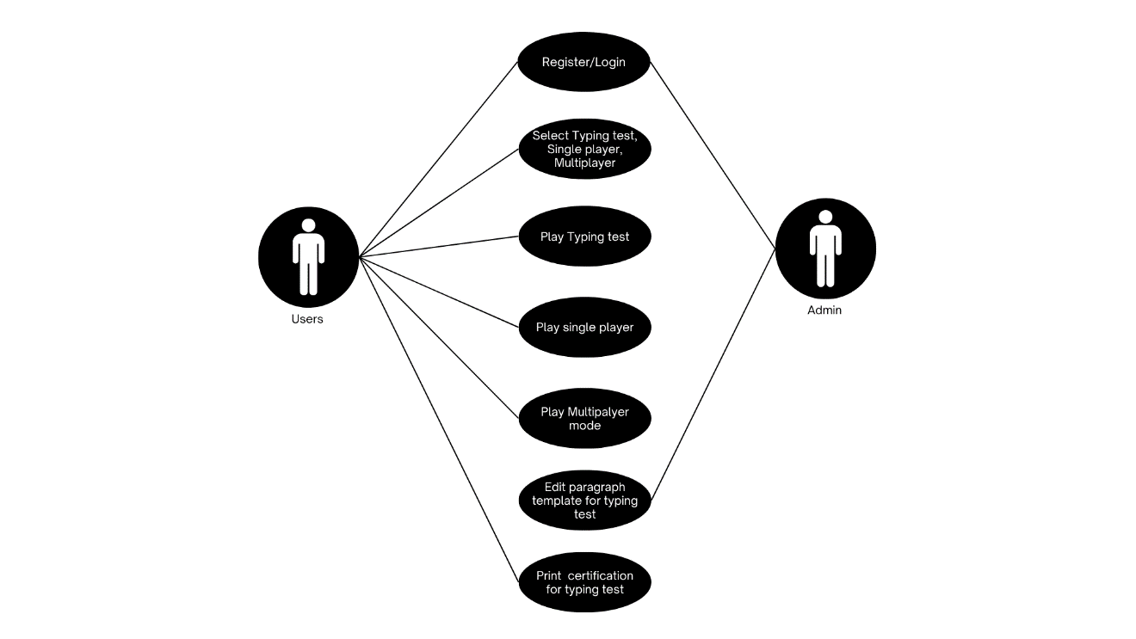
Use Case Diagram

The use case diagram for the proposed system shows the interaction between the Users and Admin with the typing test platform. The Users can register or log in, select a typing test mode such as single player or multiplayer, play typing tests, edit paragraph templates, and print certifications. The Admin can also register or log in, edit paragraph templates for the typing tests, and print certifications for participants. This diagram visually outlines the system’s functional requirements, emphasizing the specific features accessible to each actor.
Process Flow Chart. A Data Flow Diagram (DFD) is a graphical presentation of the flow of data in a system. It defines the processes which change the data, the stores where data is stored, and the external files that exchange data with the system. The elements are defined through standard symbols, and arrows indicate the direction of the movement of data. According to Herwanto (2024), DFDs are an important tool in contemporary software development because they facilitate system design, improve understanding and communication, and determine potential security and privacy issues.
Figure 3.
Process Flow Chart
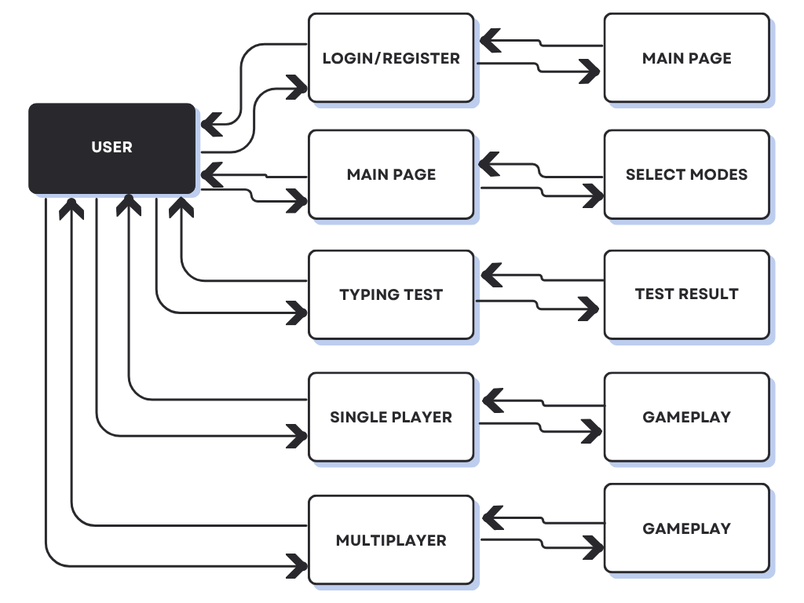
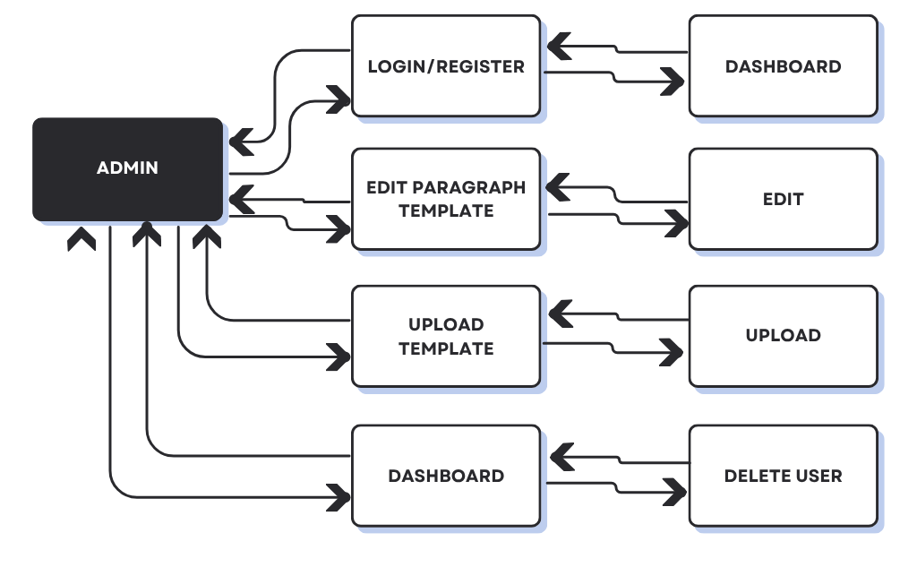
This data flow diagram illustrates the process of Certificate of Employment (COE) generation within the DEBESMSCAT HR system. It begins with the "DEBESMSCAT HR STAFF" initiating the process by submitting "Requests and Data" to the "DEBESMSCAT Personnel Database with Contract Tracking and Certificate of Employment Generation." This system then accesses two primary data stores: the "Personnel Database," from which it retrieves "Personnel Data," and the “Contract Databse," from which it retrieves "Contract Data." Both personnel and contract data, along with a "COE Data and Template," are then fed into the "COE GENERATION PROCESS." The output of this process is the "Generated COE (Digital/Print)," which is ultimately provided back to the "DEBESMSCAT HR STAFF." The diagram clearly shows the flow of information from the HR staff's request through the system's data retrieval and processing stages to the final output of the generated COE.
Technical Requirements
Hardware. Hardware refers to the physical components of a computer system, including its internal parts and connected external devices. Internal hardware manages data storage, input processing, and output delivery. External peripherals, such as monitors and printers, enable user interaction and improve the computer's usability and functionality.
The hardware specification used in the development of the proposed system is stated in detail:
Laptop Model: Matebook d15
Windows Version: Windows 11 Home Single Language
Processor: Intel Core i5
Installed Memory (RAM): 16GB DDR4 SDRAM
System Type: 64-bit Operating System, x64-based processor
Software. Britannica defines software as a collection of instructions that direct their manner of operation into a computer. It contains applications and libraries and other program-relevant non configurations data required to administer programs successfully. The general classification of software is two types: system software and application software, with system software relating to fundamental operations of the computer, such as operating systems, and device drivers, and application software being programmable to specific tasks of the user, such as editing documents or drawing graphics. Software is usually authored by software engineers and may be distributed in any given form, including on-demand downloads via the internet, storage media like CDs or DVDs or file hosting over the cloud.
The procedure of creating software is systematic and is based around a specific specification to delineate the software employed. These descriptions are as follows:

Godot Engine. Godot Engine represents the cross-platform, free-of-charge game development environment that is well-known in terms of being efficient to use to design 2D and 3D games. It has an intuitive user interface and robust scene-based architecture allowing structuring games to be built intuitively, and to be modular. Godot is based on GDScript, a Python-like distributed high-level scripting language tailored towards game development (but also suitable as a generalist scripting language). Having tools included in its frameworks (to conduct animation, physic, audio, and UI), Godot does not require any additional resources, which can be considered a self-sufficient development platform. Also, it has a low footprint, an active community and good documentation, making it perfect to use by small teams and indie developers.
Godot Engine as the main developmental tool to facilitate the 2D real time PvP typing battle game proposed. The entire coding will be GDScript, and it will be very simple to integrate such gameplay features as power-ups, combo triggers, feedback concerning the typed inputs in real-time. It will be fully developed in Godot without any use of Visual Studio or other IDEs because even the engine alone offers strong capabilities of debugging, scene, and scripting which will conclude the completion of the project.
The proposed system will utilize this platform as its server, with all features accessible only after it is launched.
Software Development Model and Procedures
In contemporary software development, linear techniques tend to fail in the face of changing requirements and accelerated market change. The Agile Model delivers a responsive alternative by emphasizing iterative development, close collaboration, and ongoing feedback. By breaking projects into short, incremental loops, Agile techniques emphasize flexibility and responsiveness, enabling teams to react rapidly to change without sacrificing intense stakeholder engagement. This method encourages delivering high-quality, user-oriented software with minimal waste, making Agile a standard of modern development methodologies.
Figure 4.
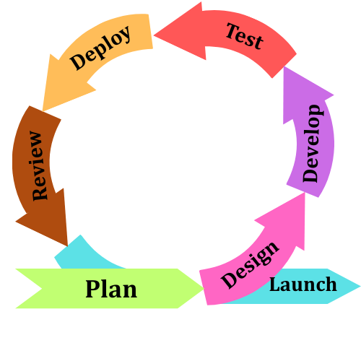
Agile Model

Here are the tasks that a developer should undertake during the development of desktop application
Plan. The initial step and the most important step in the system development is the planning phase. During this phase, developers and stakeholders have to come up with effective communication that is clear to ensure the system does not fail the users and they meet the demands and expectations of the intended users. In the case of the proposed system, the most important stakeholders will be the teacher and the students who will use the gamified typing test. In the end, planning is done with discussions on what the system will look like, how it will play, and other critical factors that will develop the system. These are such as the inclusion of customizable typing modules, tracking of results by words per minute (WPM) and accuracy, power-ups and streak bonuses to increase the engagement and the possibility of playing the game alone or with others. The feedback of the stakeholders gives worthwhile insights that can inform the developers in prioritizing features, setting goals, and defining clear project requirements. this is termed as a critical stage since it is the foundation to the system. All the choices taken in the course of planning are directly related to how the system should work, and how the user experiences it. By identifying the most critical issues discussed during this phase, the development team ensures that the project has a solid starting point, which eventually will help to facilitate the proper flow of the further stages of the Agile development cycle.
Design. is also a critical aspect of a system development, as it forms the first outline of the project. During this phase, the developers figure out how the system will look, how it will be structured and workflow, as well as, making certain the functionality and usability are taken care of correctly. At this stage, the technical resources and tools that are needed in development are known and resolved. in the case of the proposed system, the Godot Engine and the GDScript scripting language are selected to provide the basic logic of the game, such as typing controls, character behavior, and real-time interactions. Digital art programs like Ibis Paint (or other application) are used to create and design the characters, the animation and other graphical elements. This makes the game competitive but educational and makes the system attractive and interesting to the users. at this phase, the development team develops a proper guideline of how the next steps will be undertaken by adequately mapping out the technologies, user interface design, and gameplay flow. Design phase makes sure that all the requirements of the system are represented graphically and technically, which would act as a guide when it comes to the coding, testing, and application of the project.
Development. The stage of development is the one when the system is converted to a working application by using the specifications of the design. The process is very collaborative and flexible, following the Agile approach whereby developers can continually modify the system according to the feedback of stakeholders. Development is done in brief cycles called sprints, where particular features are developed, written, and tested rather than developing the complete system at once. in the case of the proposed system, the Godot Engine, using GDScript, is the main development platform that allows one to build the game mechanics of the typing-based game, including real-time combat actions, power-ups, and streak bonuses. At the same time, there are visual elements such as characters, backgrounds, and animation designed with the use of Ibis Paint that are included to make the experience more interactive. during every sprint, the development team engages closely with the stakeholders, mostly including the teachers and students, who need to collaborate to ensure that the system addresses the needs of the users. Single-player typing tests, Player vs Player (PvP) mode, Versus AI mode, performance tracking (words per minute and accuracy), and getting printable results are added and improved according to the continuous reviews. such a feedback-driven process that is iterative makes sure that the system is user-centered. Continuous collaboration and testing at all development phases ensure that the end product is not just practical but entertaining, informative, and receptive to the expectations of the target users and customers.
Testing. Testing phase is one of the crucial phases of Agile development because it makes sure that the system performs as expected and that it meets the quality requirements that were established in the planning phase. In contrast to the conventional approach, when testing is conducted in the end, when the entire system is developed, Agile incorporates testing with each sprint. This implies every feature is tested upon development and errors can be easily spotted and corrected.in the case of the proposed system, testing is done regarding both functionality and non-functionality. Functional testing is done to ensure that features like typing accuracy tracking, words-per-minute (WPM) calculation, Player vs Player (PvP) battles, Versus AI gameplay, administrator-controlled custom modules, etc. are functioning properly. Non-functional testing is concerned with usability, performance, reliability, and responsiveness, making sure the game will provide the user with smooth interactions without having input lag, crashes, or confusing interfaces.in this step, user testing is also a significant factor. Students and teachers are the main stakeholders in this case who will be invited to test the system and give feedback about its usability, level of engagement, and effectiveness in learning. This is done to make sure that the application is technically correct, but also focused on its purpose of making typing fun and efficient. also, it is checked against ISO/IEC 25010 software quality standards, which offer a systematic approach to gauge the qualities of functionality, efficiency, usability, and maintainability. Problems that arise in this step are reported and addressed on the spot, and re-tested in the following sprint, as per the concept of continuous improvement of Agile. this intensive and cooperative method means the testing process makes the final product stable, easily usable, and able to achieve both learning and entertaining objectives.
Deploy. The deployment stage is the process that involves the readiness of the system to be released and accessible to the intended users. Agile approach does not require deployment at the completion of the project, but rather it might be done at the completion of every sprint to provide systems with usable versions that could be reviewed by the stakeholders. The method applies in cases where users want to test functionalities in real-life situations, even as the developers keep perfecting the application. in the proposed system, the deployment process will consist of packaging the application into a desktop installer that can be installed within the Windows-based operating systems so that students and teachers can install and use it easily, without the need to install complex technical installations. The system is set to operate entirely offline, with all data, custom typing modules, and test results being stored in the local drive. This design option enables the system to still be useful even where there is very limited or no access to the internet. At this stage, developers as well make sure that administrator functions like adding their own text modules and setting the time limits of typing sessions are fully functional. The installation instructions and user documentation are ready to help the stakeholders with the installation and navigation of the application. The first deployment would be in a controlled setting, which is a computer laboratory, with teachers and students being able to start using the system with supervised instructions. This stage is necessary as it moves the system out of the developing prototype into a product to be used. The feedback collected at the deployment stage can be used to provide insights that can be used in future sprints to enhance the functionality, stability, and overall usability of the system.
Review. Agile development has a review stage that acts as a formal inspection of the work done in every sprint. At this level, the developers give the current iteration of the system to the stakeholders, mainly the teachers and the students, to review and evaluate. The aim of this step is to make sure that the features implemented match the requirements of users, serve the purpose of the projects, and actually work in practice. in the proposed system, some key elements that are reviewed include typing mechanism, Player Vs player (PvP) mode, Versus AI mode, power-ups, accuracy, words per minute (WPM), and printable outcomes. These features are requested to be used and to offer feedback on usability, engagement, and learning. Their feedback is used to establish if the features are ready to be deployed or need to be refined during the next sprint. It is also a stage of comparing the system with the ISO/IEC 25010 quality standards, which implies that it does not violate the main requirements of a system (such as functionality, usability, performance, and reliability). The review stage will ensure that the system is developed according to the expectations of its users by combining technical evaluations and the feedback of the users. this stage is collaborative in nature, and this way, the end product is not purely developer-based but designed by the real needs of the people who will be using it. This is because of the continuous reviews conducted after every sprint, wherein quick adjustments can be made so that the system does not become irrelevant, ineffective, and uninspiring during its life cycle.
Launch. The launch phase refers to the actual introduction of the system to be in full use by its target audience. Agile development does not bring the process to an end, but it is the culmination of several sprints, reviews, and stakeholder feedback. At this point, the system is tested, refined, and validated to make sure that it satisfies the needs of the teachers and students. In the case of the proposed system, the launch is performed through the introduction of the desktop application in school computer laboratories or individual student computers. The teacher functions of the administrator are provided, where the teachers can create or upload typing modules, set the duration of the tests, and get printable results. On the other hand, students are able to access the gamified type scenario instantly and engage in Player vs Player (PvP) duels or Versus AI, and monitor their progress using words-per-minute (WPM) and accuracy. user manuals, installation guides, and training are some of the options that may be provided to support the launch to facilitate smooth adoption. A pilot launch can be done first in one class or section to observe performance and receive first feedback, and then rolled out over a wider scale. This assists in the determination of any last-minute problems that need to be resolved before complete deployment. The launching stage is important as it will shift the system out of the development stage, and an actual learning tool will be developed and used to increase typing habits. It also makes it possible to estimate its success in enhancing student commitment, typing proficiency, and assisting educators in keeping track of the progress.
Software Cost Estimation
Software Cost Estimation (SCE) is a significant challenge in software engineering, as inaccurate estimates can severely impact software companies. Researchers have worked to improve SCE models, with the Constructive Cost Model (COCOMO) being a widely used approach (Gandomani, Dashti & Nafchi, 2022).
COCOMO is a structured method for estimating the cost, effort, and duration of software projects, organized into three levels: Basic, Intermediate, and Detailed. Basic COCOMO provides an initial effort estimate based on project size, using simple equations that consider lines of code, function points, or object points (Gandomani, Dashti & Nafchi, 2022). Intermediate COCOMO refines this by including factors like project complexity, development environment, and team experience, allowing for more informed resource allocation and planning (Gandomani, Dashti & Nafchi, 2022). Detailed COCOMO offers the most precise estimate by considering personnel capabilities, project management practices, and organizational complexity, although it requires more detailed project information (Gandomani, Dashti & Nafchi, 2022).
Accurate SCE is crucial for effective project planning, resource allocation, and risk management in software engineering (Zhang et al., 2023), enabling realistic goal setting and improved project success. In mobile app development, precise cost estimation is particularly vital due to rapid innovation and tight schedules (Murad, Abdullah & Rosli, 2021).
In summary, SCE, especially through models like COCOMO, is vital for software project management. By segmenting the estimation process and considering various influencing factors, COCOMO helps project managers make informed decisions, reduce risks, and increase project success, ultimately contributing to the efficiency and sustainability of software development.

References
Abisornam, M. (2025). Document verification system. International Journal of Scientific Research in Engineering and Management, 9(5), 1-9. https://doi.org/10.55041/IJSREM46911

Acedo, G. G. (2025). Web-Based Document Tracking System for Catanduanes State University with QR-Code Technology: In Alignment with Republic Act No. 11032. Journal of Information Systems Engineering & Management, 10(6s), 469–477. https://doi.org/10.52783/jisem.v10i6s.745
Aguinis, H., Cope, A., Martin, U., & Yokoya, R. (2025). Transparency, reproducibility, and replicability in human resource management research. Personnel Review. Advance online publication. https://doi.org/10.1108/PR-10-2024-0946
Aguinis, H., & Gibson, B. C. (2025). Making waves: How to improve scholarly impact performance through stakeholder engagement. BRQ Business Research Quarterly, 28(2). https://doi.org/10.1177/23409444251316310
Alvi, S. H. (2024). From Automation to Empowerment: Harnessing the Power of AI in Human Resources. International Journal For Multidisciplinary Research, 6(1). https://doi.org/10.36948/ijfmr.2024.v06i01.12910
Anwar, S., & Hermina, N. (n.d.). The Effect of Job Training and Professional Certification on Job Opportunities (case Study at PT Akasia Multi Talenta). https://doi.org/10.31538/iijse.v7i3.5740
Aprilina, V., Dompak, T., Salsabila, L., & Lodan, K. T. (2025). The role of digitalization in enhancing public service efficiency: Challenges and opportunities in managing public complaints through e-government in Indonesia. International Journal of Social Welfare and Family Law, 2(1), 57-66. https://doi.org/10.62951/ijsw.v2i1.183
Ballamudi, V. K. R. (2022). Unlocking the Power of Agile Methodology: A Journey to Developing Software and Web Applications. Engineering International. https://doi.org/10.18034/ei.v10i2.677
Bansal, V. (2023). Automating HR Processes: Streamlining Employee Management. International Journal for Research Publication and Seminar, 14(4), 49–58. https://doi.org/10.36676/jrps.2023-v14i4-007
Bizzarro, C., Pasquini, F., Tiraboschi, M., & Venturi, D. (n.d.). The Certification of Employment Contracts: A Legal Instrument for Labour Market Regulation in Italy. https://doi.org/10.54648/ijcl2010007
Cai, C.-H., Sun, J., & Dobbie, G. (2020). Measuring the Quality of B Abstract Machines with ISO/IEC 25010. arXiv: Software Engineering. https://arxiv.org/abs/2003.02619
Castro, F., Paculan, E. R. Q., & Arruejo, A. C. (2022, December). DocTrack: A Dynamic Document Tracking System for the University of Northern Philippines. [Conference presentation or unpublished manuscript]. https://doi.org/10.69478/JITC2022v4n2a03
Chatterjee, S., Chaudhuri, R., Vrontis, D., & Siachou, E. (2021). Examining the dark side of human resource analytics: An empirical investigation using the privacy calculus approach. International Journal of Manpower, ahead-of-print(ahead-of-print). https://doi.org/10.1108/IJM-02-2021-0087
Coelho, I., Ventura, P., & Reis, L. (2020). Design of Model and Application Development for Agile Practices Assessment. Iberian Conference on Information Systems and Technologies, 1–5. https://doi.org/10.23919/CISTI49556.2020.9140849
Dreichuk, M., & Sytnyk, Y. (2025). HR analytics as a risk monitoring tool in personnel management systems. Economics & Education, 10(1), 22–28. https://doi.org/10.30525/2500-946X/2025-1-3
Dundon, T., & Wilkinson, A. J. (2020). Work, employment and human resource management: Case study applications. Edward Elgar Publishing. https://doi.org/10.4337/9781788975599.00005
Dursun, D., & Yawar, M. E. (2025). A comprehensive review of the role and importance of strategic human resource, human resources management practices and human capital management. Journal of Economics and Business, 8(2), 28-34. https://doi.org/10.31014/aior.1992.08.02.660
Ebrahimi, A. M., Adams, B., Oliva, G. A., & Hassan, A. E. (2025). UPC sentinel: An accurate approach for detecting upgradeability proxy contracts in Ethereum. Empirical Software Engineering, 30(61). https://doi.org/10.1007/s10664-024-10609-7
Esang, M., Johnson, E. A., Attai, K., Inyangetoh, J. A., Dan, E., Okonny, K. E., Bardi, I., Bassey, A., & John, A. (2024). Exploring Agile Methodology in Developing a Web-Based Result Computation and Transcript System: A Case Study of Federal Polytechnic Ukana. European Journal of Computer Science and Information Technology, 12(4), 1–17. https://doi.org/10.37745/ejcsit.2013/vol12n4117
Geoloni, G. D., & Agushinta R, D. (2023). Web-Based Human Resource System Quality Analysis Using ISO 25010:2011 Method Based on Usability Characteristics. https://doi.org/10.32520/stmsi.v12i2.2791
Ghamri, R. M., Fadhel, N. F., & Wills, G. (2020). Investigating trusted records for employment and education. The Internet of Things, 412–4419. https://doi.org/10.5220/0009489504120419
Gour, M. M., Rao, R. P. S., & Singh, A. (2024). The Impact of Automated Systems on HRM Algorithms in Multinational Companies. 1–6. https://doi.org/10.1109/icccnt61001.2024.10725402
Gray, J. S., Baker, E. W., Simmonds, D., & Cummings, J. (2018). A Comparative Analysis of Agile Project Management Methodologies. Annals of the Master of Science in Computer Science and Information Systems at UNC Wilmington, 12(1). https://uncw.edu/csb/MSCSIS/complete/pdf/Gray_James.pdf
Hazafi, Z., & Pintér, N. (2020). The introduction of HR knowledge exchange system and expert network in Hungarian civil service to support the reorganisation of personnel management. In Central and Eastern European eDem and eGov Days (Vol. 335, pp. 67-79). Austrian Computer Society. https://doi.org/10.24989/ocg.v.338.5
Hermosa, K. R. (2023, December). DOCUMENT MANAGEMENT SYSTEM WITH TRACKING AND MONITORING IN MANUEL S. ENVERGA UNIVERSITY FOUNDATION-CANDELARIA INC. International Journal of Advanced Research in Computer Science, 14(6), 31–43. https://doi.org/10.26483/ijarcs.v14i6.7038
Jadhav, P., Godambe, A., Gaikwad, R., & Deshpande, K. (2022). Online Certificate Generation and Verification Using Blockchain Framework (pp. 217–225). Springer, Singapore. https://doi.org/10.1007/978-981-16-5301-8_16
Kalwar, A., Shekhawat, D., Singhal, S., & Shekhawat, J. S. (2023). An Extended Approach of Agile Model towards Agile Requirement Quality Inspector. 39:1-39:5. https://doi.org/10.1145/3647444.3647865
Kim, S., & Kim, D. (2024). Data-Tracking in Blockchain Utilizing Hash Chain: A Study of Structured and Adaptive Process. Symmetry. https://doi.org/10.3390/sym16010062
Kotsur, A., Ostroverhov, V., Diakiv, O., & Prokhorovska, S. (2024). Personnel audit and HR analytics as tools for effective human resource management in an organization. Regional’ni Aspekti Rozvitku Produktivnih Sil Ukraїni, 1(29), 87-93. https://doi.org/10.35774/rarrpsu2024.29.087
Krishna, M. V., Shree, A. K., Sri, Ch. L., Vasu, G., & Sreya, K. V. N. (2024). Generation and Validation of E-Certificate using Blockchain. https://doi.org/10.1109/icaaic60222.2024.10575434
Krishnan, M. S., & Ganesh, P. (2024). A Study on Impact of AI and Automation on HR in it Sector. Emperor Journal of Finance, 03(05), 96–103. https://doi.org/10.58394/ejf.2024.3510
Laudza, N. A. S., & Sofyan, H. (2024). Evaluasi Kualitas Sistem Informasi Akademik dengan Standar ISO/IEC 25010 (Studi Kasus: Universitas ABC). Telematika: Jurnal Informatika Telekomunikasi Komputasi Elektronika Dan Industri, 21(2), 158. https://doi.org/10.31315/telematika.v21i2.12406
Latupeirissa, J. J. P., Dewi, N. L. Y., Prayana, I. K. R., Pramana, I. B. G. A. Y., et al. (2024). Transforming public service delivery: A comprehensive review of digitization initiatives. Sustainability, 16(7), 2818. https://doi.org/10.3390/su16072818
Liu, D., Cheng, Y., & Zhang, Z. (2020). Intelligent contract stain tracking method and device.
Lukyanov, I. S., & Borodin, A. V. (2025). Evaluation of human resource management efficiency in IT companies based on a balanced scorecard. Economics and Management, 31(5), 602-612. https://doi.org/10.35854/1998-1627-2025-5-602-612
Moumane, K., Idri, A., El Aouni, F., Laghnimi, J., Chaouni Benabdellah, N., & Hamal, O. (2024). ISO/IEC 25010-based Quality Evaluation of Three Mobile Applications for Reproductive Health Services in Morocco. https://doi.org/10.31083/j.ceog5104088
Mulyawan, M. D., Kumara, I. N. S., Swamardika, I. B. A., & Saputra, K. O. (n.d.). Kualitas Sistem Informasi Berdasarkan ISO/IEC 25010: Literature Review. https://doi.org/10.24843/mite.2021.v20i01.p02
Murphy, L. (2024). The productivity dilemma: examining the truth behind automation’s impact on employment, and the mediating role of augmentation. The International Journal of Organizational Analysis. https://doi.org/10.1108/ijoa-04-2024-4430
Nadtochii, I. (2024). Economic prerequisites, development trends and features of the implementation of HR technologies through the prism of digital transfor-mations. Ukrainian Journal of Applied Economics and Technology, 9(1), 261-265. https://doi.org/10.36887/2415-8453-2024-1-44
Navarro, L. F. B., Barbaso, L. V., & Aliac, C. J. (2025, February). TRACKERB: HOLY NAME UNIVERSITY ETHICAL REVIEW BOARD DOCUMENT TRACKING SYSTEM. [Conference presentation or unpublished manuscript]. https://doi.org/10.5281/zenodo.14936409
Nawaz, N., & Gomes, A. M. (2014). Automation of the HR functions enhance the professional efficiency of the HR Professionals-A Review. International Journal of Managment, IT and Engineering, 4(2), 364–373. https://www.indianjournals.com/ijor.aspx?target=ijor:ijmie&volume=4&issue=2&article=031
Nurunnisa, F., Hamzah, M. L., & Saputra, E. (2024). Analyzing the Quality of Web-Based Scholarship Information System Using ISO/IEC 25010 Standard. 1–6. https://doi.org/10.1109/iccsc62074.2024.10617354
Nuzula, M. I. F., & Rochimah, S. (2023). Evaluation of Service Quality in Human Resource Information Systems Using the ISO/IEC 25010. https://doi.org/10.1109/isemantic59612.2023.10295365
Ononiwu, A. (2025). Optimizing HR Processes with a Web-Based System: Innovations in HR Recruitment, Staff Deployment, and Document Management. https://doi.org/10.36227/techrxiv.173687863.38914889/v1
Parveen, N., Malpani, A., Rasheed, T., & Sultana, M. (2024). Deployment of AI Model to Analyze the Automation Process of HR. 1050–1056. https://doi.org/10.1109/icdt61202.2024.10489007
Pazare, S. (2024). HR Automation: Enhancing Candidate Onboarding Processes. Indian Scientific Journal Of Research In Engineering And Management. https://doi.org/10.55041/ijsrem31260
Purbaratri, W., Hartomo, K. D., & Tambotoh, J. J. C. (2023). The New Smart Government Software Quality Framework Uses Modifications to ISO/IEC 25010. 1–6. https://doi.org/10.1109/icic60109.2023.10382109
Putri, S. A., Dewi, I. K., & Afrina, A. (2025). Designing and developing a web-based information system for incoming and outgoing letters management. Journal of Computer-based Instructional Media, 3(1), 41-57. https://doi.org/10.58712/jcim.v3i1.143
Qutni, D., Kristiawan, M., & Fitriani, Y. (2021). Human resource management in improving the quality of education. Edunesia: Jurnal Ilmiah Pendidikan, 2(2), 354-366. https://doi.org/10.51276/edu.v2i2.132
R, N., S, R., A, C., Reddy, Y. P. M., & M, P. (2024). Online Blockchain Based Certificate Generation and Validation System. International Journal of Advanced Research in Science, Communication and Technology. https://doi.org/10.48175/ijarsct-18069
Romano, B. L., & Cunha, A. M. da. (2021). An Agile MDD Method for Web Applications with Modeling Language (pp. 519–525). Springer, Cham. https://doi.org/10.1007/978-3-030-70416-2_67
Rumabar, B. I., & Maria, E. (2023). Evaluasi Kualitas Shopeepay Menggunakan ISO/IEC 25010. Jurnal Sistem Informasi Bisnis. https://doi.org/10.21456/vol14iss1pp54-61
Saju, S., Sabu, I. R., & Anita, E. A. M. (2024). Certificate Generation and Validation Using Blockchain (pp. 275–282). Springer International Publishing. https://doi.org/10.1007/978-981-99-9043-6_23
Shanmugam, V., Sibi, M. S., Thuraisingham, B., Paneru, D. R., & Karumpan, S. (2024). Navigating the Opportunities and Challenges of AI and Automation in Human Resource Development. Advances in Computational Intelligence and Robotics Book Series, 103–128. https://doi.org/10.4018/979-8-3693-5380-6.ch005
Shen, C., Hong, B., Ruan, X., & Xu, L. (2020). Document template generation method and device.
Smolarek, A., & Budzynowski, K. (2025). The potential applications of artificial intelligence in human resource management. Zeszyty Naukowe Wyższej Szkoły Humanitas. Zarządzanie, 26(2), 29-46. https://doi.org/10.5604/01.3001.0055.2046
Stepanov, D. Y. (2021). Using Agile Methodology in ERP-system Implementation Projects. https://doi.org/10.1109/INFOTECH52438.2021.9548342
Sudianjaya, N. R., & Rochimah, S. (2023). Goal-Oriented Functional Suitability Measurement on Loan Origination System Based on ISO/IEC 25010. 161–165. https://doi.org/10.1109/ic3ina60834.2023.10285765
Suganthi, M., Raja, G. P., & Muthurasu, C. (2025). Role of human resource management in education. Shanlax International Journal of Arts Science and Humanities, 12(S1-May), 43-46. https://doi.org/10.34293/sijash.v12iS1-May.8976
Sundari, S., Mardame Silalahi, V. A. J., Wardani, F. P., Siahaan, R. S., Sacha, S., Krismayanti, Y., & Anjarsari, N. (2024). Artificial Intelligence (AI) and Automation in Human Resources : Shifting the Focus from Routine Tasks to Strategic Initiatives for Improved Employee Engagement. EAJMR East Asian Journal of Multidisciplinary Research, 3(10), 4983–4996. https://doi.org/10.55927/eajmr.v3i10.11758
Surachman, A. (2024). Optimasi Pengalaman Pengguna: Evaluasi ISO/IEC 25010 pada Penjualan Online. STRING (Satuan Tulisan Riset Dan Inovasi Teknologi). https://doi.org/10.30998/string.v8i3.19324
Sutharsan, M. E., & Vijayakumar, K. (2023). Smart performance analysis of human resource automation in information technology industry. ICTACT Journal on Management Studies, 09(01), 1707–1711. https://doi.org/10.21917/ijms.2023.0257
Suzuki, M., & Kotani, S. (2014). Certificate generation method, certificate generation apparatus and information processing apparatus.
Svatiuk, O., Zaharets, A., & Sytnyk, Y. (2022). Digitization of managerial work of HR-manager. Scientific Messenger of Uzhhorod National University. Series: Economics, 2022(2), 210-222. https://doi.org/10.23939/smeu2022.02.210
Taslim, W. S., Rosnani, T., & Fauzan, R. (2024). The Impact of Work Automation on Human Resource Decision Making: The Mediating Role of Employee Performance. International Journal of Social Science and Human Research, 07(12). https://doi.org/10.47191/ijsshr/v7-i12-46
Tiwari, R., Bhardwaj, G., & Tiwari, P. (2024). Analyzing HR Management and its Impact using Machine learning Algorithms. 985–991. https://doi.org/10.1109/ic3i61595.2024.10829027
Thomas, S. A., & Bindu, V. R. (2022). Growth of agile software development methodologies in a web apps scenario. Nucleation and Atmospheric Aerosols. https://doi.org/10.1063/5.0104389
Velasquez, J. M. C., Cochanco, A. S., & Luciano, R. G. (2023). Enhancing Support For Senior Citizens: Development And Evaluation of The OSCA Information Management System With Agile Methodology and ISO/IEC 25010 Compliance. Journal of Applied Engineering and Technological Science. https://doi.org/10.37385/jaets.v5i1.3062
Vijai, C., & Mariyappan, M. S. R. (2023). Robotic Process Automation (RPA) in Human Resource Functions. Advances in Management, 16(3), 30–37. https://doi.org/10.25303/1603aim030037
Westover, J. (2024). Driving Employee Engagement through HR Automation. Human Capital Leadership., 16(1). https://doi.org/10.70175/hclreview.2020.16.1.10
Wisnumurti, W., Trimarsiah, Y., & Faulina, S. T. (2022). Penerapan agile development methodology pada sistem informasi penjualan ecer dan grosir toko kinanti martapura. https://doi.org/10.32767/jutim.v7i2.1727
Yatsyshyn, V. V., Pastukh, O. N., Palamar, A., & Zharovskyi, R. (2023). Technology of relational database management systems performance evaluation during computer systems design. Вісник Тернопільського Національного Технічного Університету, 109(1), 54–65. https://doi.org/10.33108/visnyk_tntu2023.01.054
Yulianty, A., & Kurniawati, A. (2021). Quality analysis of bios portal website at banking companies using iso/iec 25010: 2011 method. Int. Res. J. Adv. Eng. Sci, 6(2), 11-16.
Zachosova, N., Bilous, S., & Lych, Y. (2025). People-centric HR-management: Enhancing recruitment, motivation and intellectual-personnel security of enterprises. Economics Finance and Management Review. https://doi.org/10.36690/2674-5208-2025-2-109-119
Zhang, C., Li, B., Wang, L., Xu, H., & Shao, T. (2022). A Hierarchical Model for Quality Evaluation of Mixed Source Software Based on ISO/IEC 25010. International Journal of Software Engineering and Knowledge Engineering, 33, 181–205. https://doi.org/10.1142/s021819402250070x

s

